**Source :**-  Series File

**Objective:** Create a measure to rank each series by its viewing figures.

You have to connect and clean the data in the Power BI Desktop and then look for relationships in the Model View. Now create a new column using DAX expression to have ranks in ascending order.

Clean the data before we implement the DAX expression and creating the report.

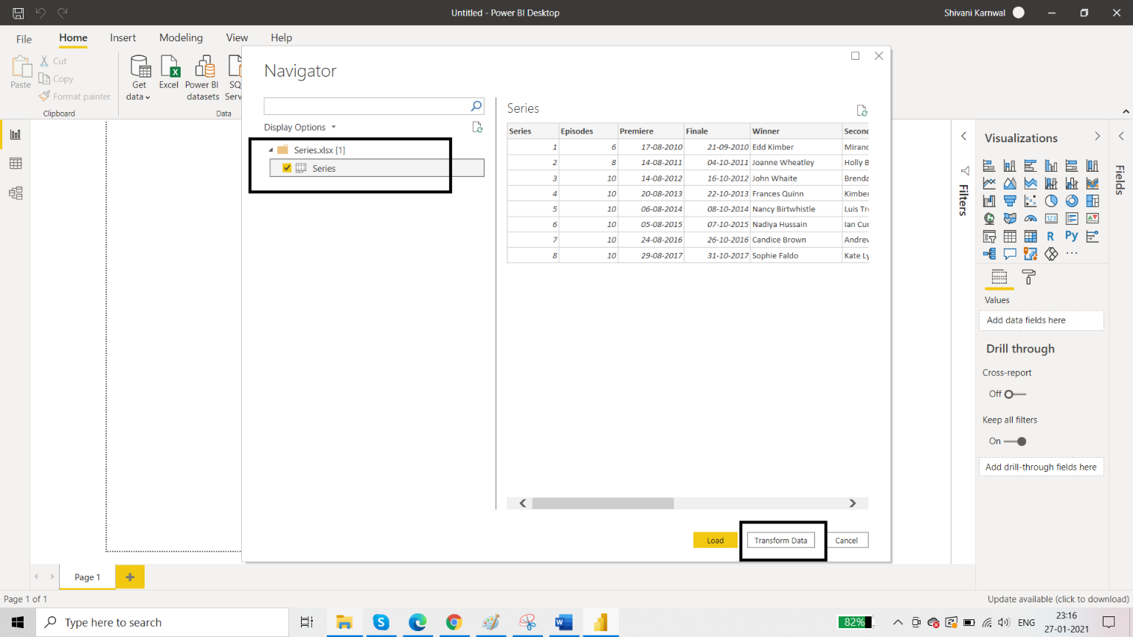

**DAX Formula:**

***Rank = RANKX(ALL(Series), CALCULATE(SUM(Series[Viewers (m)])), ,ASC)***

